Once you know a bit more about your audience, you can also think about: what is their preferred way of communicating?  
﻿﻿

Let's talk about 4 types of preferences, with practical tips how to communicate for each preference.

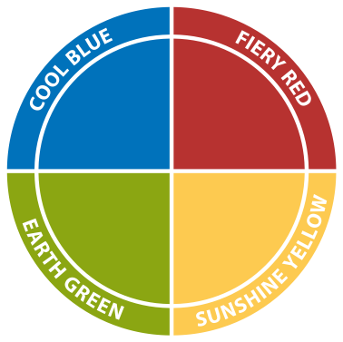

﻿﻿

*<Editing Guidelines: see the below picture, also in PPT all the way below*

*When I describe these for types of colors / preferences, please zoom in on each color when I talk about that color (I mean: only show that color quadrant, including the descriptions (e.g. Competitive, Demanding, etc.). Grey out the others. Also, please add the Do's and Don'ts for that color, in text, on the screen.>*﻿﻿  
﻿﻿

﻿﻿

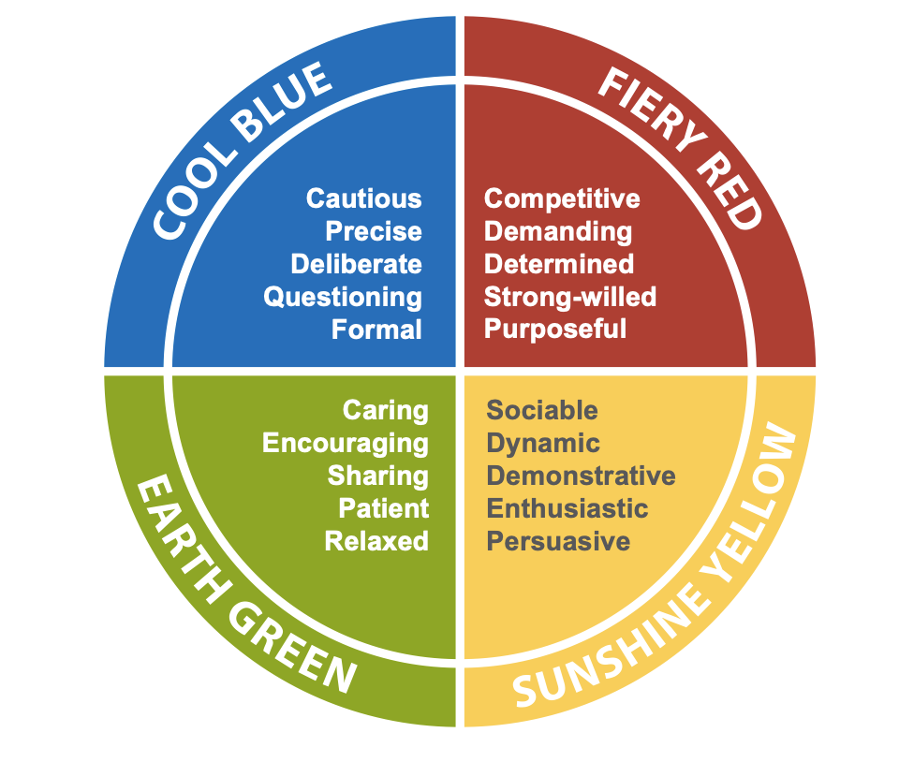

🔷 **Cool** 𝗕𝗟𝗨𝗘:

▪️ Personality: analytical

▪️ Need: facts, time to process, ask questions

▪️ What to do:

***Do***

* Send work in advance, bring relevant data, be ready for in-depth questions.
* Meet one on one, ask for feedback and solicit new ideas and recommendations.

***Don't***

* pressure analytical personalities into making a decision quickly  
   ﻿﻿

﻿﻿

﻿﻿

🔥 **Fiery** 𝗥𝗘𝗗:

▪️ Personality: direct, action-oriented

▪️ Need: direct communication, action

▪️ What to do:

***Do***   
﻿﻿don't beat around the bush. Come to the point. Focus on decisions.

be efficient, confident and assertive in your communications. Align your recommendations to current goals, tie data directly to results and explain how understanding it will help achieve objectives.

***Don't***   
﻿﻿go too deep into extraneous detail or waste time in your communications. Drivers will listen to facts but are more likely to "move fast and break things" versus revisiting the numbers again and again.

﻿﻿

﻿﻿

☀️ **Sunshine** 𝗬𝗘𝗟𝗟𝗢𝗪:

▪️ Personality: energetic, bubbly

▪️ Need: fun, creativity

▪️ What to do:

***Do***﻿﻿

Use data storytelling to get their attention. Present lively figures. Focus on the bigger picture (connect it to a vision)

***Don't***   
﻿﻿get into monotonous details or send long impersonal emails.

﻿﻿  
﻿﻿

﻿﻿

🏝 **Earth** 𝗚𝗥𝗘𝗘𝗡:

▪️ Personality: relaxed

▪️ Need: harmony

▪️ What to do: don't be too direct. Be curious about personal life and ask for their opinion.

***Do***   
﻿﻿Take your time to engage them on a personal level. Translate the impact of the data on the employees, customers, partners and other people. Let them know that you have an opinion, but reassure them that you value and welcome their opinions, too.

﻿﻿***Don't***   
﻿﻿behave in an autocratic way. When pushed, amiable types may “give in” without agreeing or just stop listening to you altogether.

﻿﻿  
﻿﻿  
﻿﻿

**People are unique. No one “is” one color - everyone has a mix. But most people do have preferences.  
﻿﻿**

When you take those preferences into account, you increase the chance that people understand and use your insights.

﻿﻿

﻿﻿

**Often, it's hard to guess. You'll make assumptions. So it's always best to ask!**

"Before we start, I'd like to ask you: to make this meeting effective, what is important to you? "

They will tell you: clear agenda, going into the details, goals, clear next steps, involvement of people, etc.

### 

### **﻿﻿**

**So, next time when you talk about data -**

Take a moment to think:

﻿﻿  
﻿﻿

𝗪𝗛𝗢 𝗮𝗺 𝗜 𝘁𝗮𝗹𝗸𝗶𝗻𝗴 𝘁𝗼?  
﻿﻿  
﻿﻿What are their communication preferences?

What can I do to get my insights across?

### 

### **﻿﻿**

﻿﻿

=======

@Otavio: ignore all notes below.

﻿﻿

====

﻿﻿

**ADD PDF slide DECK OF INSIGHTS DISCOVERY!!!**

**As hand-out**

﻿﻿

====

Also add hand-out: how to communicate with different kind of people

﻿﻿

How to deal with MIXED AUDIENCES?

A bit for everyone.

Mainly think: what is their business goal? What is their challenge?

Be explicit in showing that you understand what's important for others

(I know for you it's important to..." / "You told me you'd like to reach a decision by the end of this meeting)

﻿﻿

-=====  
﻿﻿

### **If you want to learn more about these different communication styles, I recommend this funny TED talk (EMBED IN HERE!):** [**https://www.youtube.com/watch?v=8pq_tCgDkT4&t=155s**](https://www.youtube.com/watch?t=155s&v=8pq_tCgDkT4)

﻿﻿

﻿﻿

﻿﻿

﻿﻿

**Sources:**

* Insights Discovery model  
  ﻿﻿
* Forbes article:  
  [﻿﻿https://www.forbes.com/sites/forbestechcouncil/2022/10/11/data-eq-using-emotional-intelligence-to-build-consensus-around-data/?sh=5190ff272ad8](https://www.forbes.com/sites/forbestechcouncil/2022/10/11/data-eq-using-emotional-intelligence-to-build-consensus-around-data?sh=5190ff272ad8)

﻿﻿  
﻿﻿